## Executive summary

We exported data from Kaggle and we conducted sum analysis on it to gain insights

### Scope

* Average salary for jobs
* The size of the companies deployed
* Prevalent jobs in terms of workplace
* Categories of work in terms of experience
* The type of employment that is widespread in terms of remote work

# Analysis

* Average salary for jobs

* What the Average salary for each jobs and which the job is the most?

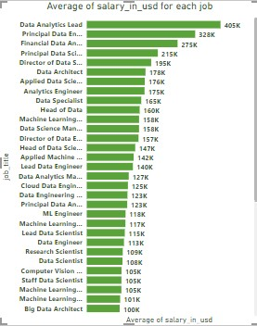

From chart we note that the data analysis lead is the most job in in average salary

Recommendation

if we need a big salary it’s the job Recommended

* The size of the companies deployed

what is the most company in this field ?

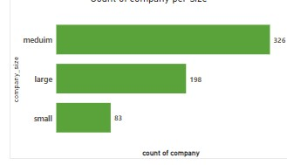

From chart we note that the medium company is the most in data jobs and a Little of small company .

Recommendation

If you want to get a job search and focus in the medium and large company

* The type of employment that is widespread in terms of remote work
* What is the most type of employment that is widespread in terms of remote work and What is the expectation that this will happen?

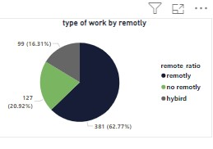

From chart we note that the remotely employment is the most type and I expect in the future that this interest will increase because the world is turning to this type to save expenses.

Recommendation

If you want to get a job foucs search in a remotely job

because it is the most type

* Prevalent jobs in terms of workplace

What is the most type of work in data jobs?

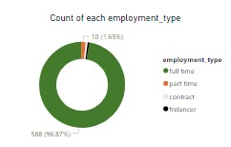

From the chart we note that the full time employment is the most type.

* Categories of work in terms of experience

What is the most level of experience in company and why ?

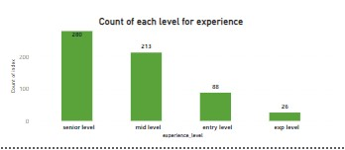

From chart we note that the senior level is the most level because the most company is a medium and large company so theyn need the experience in work.

​